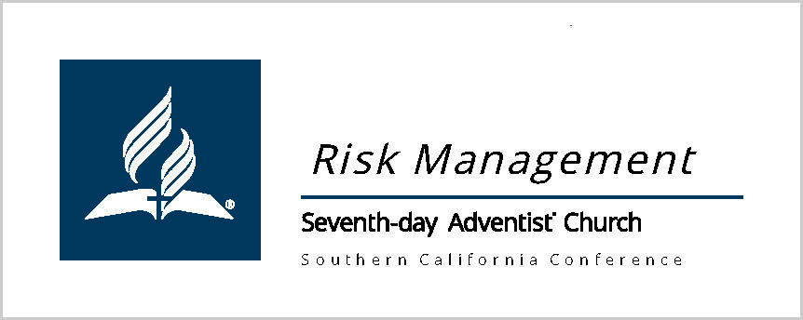

From Risk Management, for Principals and School offices:

- Always obtain signed contracts and Certificates of Insurance (COI) BEFORE someone or an entity, other than our own SCC entities, uses any portion of the school sites.
  - All SCC entities are under one insurance policy. No COI required. However, still have a signed contract if staying on campus – i.e. band trip etc., or hosting their own function.
  - Any visiting alternate Conference Adventist school or church, using facilities, are under a different policy. They need to provide a COI and sign a contract, if staying on campus or using the gym for their own functions.
  - Certificates of Insurance (COI). VERY IMPORTANT: A Certificate of Insurance (COI) naming SCC's school entity and address, and Southern California Conference. Wording should be: Additional Insured: _____________ School of Seventh-day Adventists, and Southern California Conference of Seventh-day Adventists, their Officers, Agents, Employees and Volunteers. 1535 East Chevy Chase Drive, Glendale California 91206. Each COI must cover $2,000,000 general and $3,000,000 aggregate.

- A lease or short-term rental agreement, which can cover the full dates of the sports season. Here are templates on SCC's Asset Management site where options can be found.
https://scc.adventist.org/departments-ministries/asset-risk-management/asset-management/forms?_bare=1&_t=1594087589#lease.
A school can modify one of the church templates to state "school" if needed.
- Injuries: If ANYONE, even a guest on campus, gets hurt to the point of needing medical attention, please keep an incident file in the school office, including date, time, what occurred, who (Employee) witnessed. This is simply logical record keeping. Please get pictures of injury location at the very least, at the time of the incident to be filed with the incident report. (Protecting school and conference for future litigations.)
- Student Accident Insurance: Injuries MUST be reported within 30 days of the incident. ANY student injury that requires medical attention should be reported, so that it is on file.
The company is "Relation”. Each Administrator is provided, from Relation with a unique code and reporting platform after the beginning of the school year. Watch for email from Relation directly. Administrators can use their same unique code from last year; 2022-23 info will be emailed after open reports.
  - https://www.admin.renstudent.com/Home/Account/Login
  - Administration / school offices can access all the information on the K-12 Adventist Group website, www.k-12accidentmedical.com . As a reminder, the ID card should be given to the parent of the injured child so they can present their primary insurance ID card and this card so the provider will file with both companies. The 2022-23 ID cards will be available on the K-12 site late September/early October. If an accident occurs prior to the updating with this year’s info, contact Relation Insurance Services office (800) 955-1991 / direct (913) 754-2591.

