CREW LEADERS
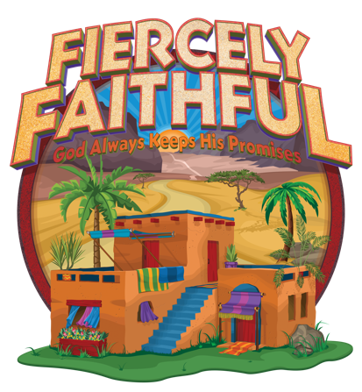
SCAOUTS / BLUE |  |  |  | NOMADS / YELLOW
 |  | LEADER |  |  | LEADER
1 |  |  |  | 3
2 |  |  |  | 4
MERCHANTS / RED |  |  |  | PILGRIMS / PURPLE
 |  |  | LEADER |  | LEADER
5 |  |  |  | 7
6 |  |  |  | 8
GUARDS / GREEN
 | LEADER
9
10

