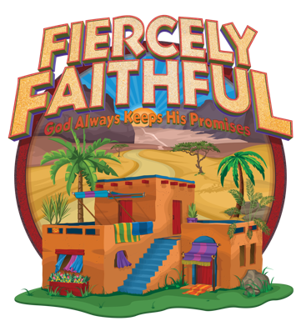
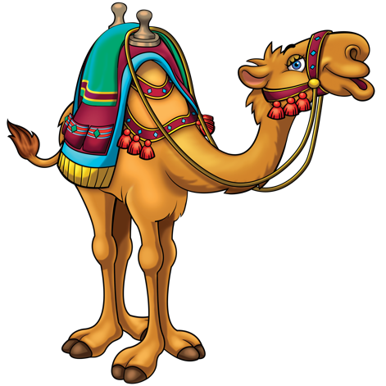
FIERCELY FAITHFUL ATTENDANCE

Crew # 1
Leader: _________________________________

CHILDREN’S NAMES | AGE | S | M | T | W | T | F
1.
2.
3.
4.
5.
6.
7.
8.

Each Crew is form with children of different ages ranging from 3-12.
Younger / pre-school age kids have their own program and meet separately

FIERCELY FAITHFUL ATTENDANCE

Crew # 2

Leader: _________________________________

CHILDREN’S NAMES | AGE | S | M | T | W | T | F
1.
2.
3.
4.
5.
6.
7.
8.
FIERCELY FAITHFUL ATTENDANCE

Crew # 3
Leader: _________________________________

CHILDREN’S NAMES | AGE | S | M | T | W | T | F
1.
2.
3.
4.
5.
6.
7.
8.

Each Crew is form with children of different ages ranging from 3-12.
Younger / pre-school age kids have their own program and meet separately

FIERCELY FAITHFUL ATTENDANCE

Crew # 4

Leader: _________________________________

CHILDREN’S NAMES | AGE | S | M | T | W | T | F
1.
2.
3.
4.
5.
6.
7.
8.
FIERCELY FAITHFUL ATTENDANCE

Crew # 5
Leader: _________________________________

CHILDREN’S NAMES | AGE | S | M | T | W | T | F
1.
2.
3.
4.
5.
6.
7.
8.

Each Crew is form with children of different ages ranging from 3-12.
Younger / pre-school age kids have their own program and meet separately

FIERCELY FAITHFUL ATTENDANCE

Crew # 6

Leader: _________________________________

CHILDREN’S NAMES | AGE | S | M | T | W | T | F
1.
2.
3.
4.
5.
6.
7.
8.
FIERCELY FAITHFUL ATTENDANCE

Crew # 7
Leader: _________________________________

CHILDREN’S NAMES | AGE | S | M | T | W | T | F
1.
2.
3.
4.
5.
6.
7.
8.

Each Crew is form with children of different ages ranging from 3-12.
Younger / pre-school age kids have their own program and meet separately

FIERCELY FAITHFUL ATTENDANCE

Crew # 8

Leader: _________________________________

CHILDREN’S NAMES | AGE | S | M | T | W | T | F
1.
2.
3.
4.
5.
6.
7.
8.
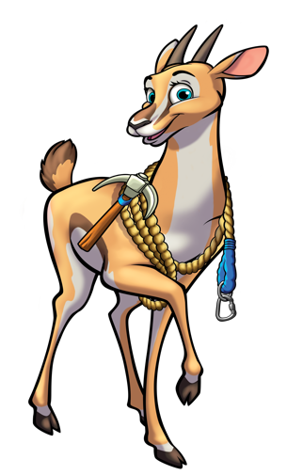
FIERCELY FAITHFUL ATTENDANCE

Crew # 9
Leader: _________________________________

CHILDREN’S NAMES | AGE | S | M | T | W | T | F
1.
2.
3.
4.
5.
6.
7.
8.

Each Crew is form with children of different ages ranging from 3-12.
Younger / pre-school age kids have their own program and meet separately

FIERCELY FAITHFUL ATTENDANCE

Crew # 10

Leader: _________________________________

CHILDREN’S NAMES | AGE | S | M | T | W | T | F
1.
2.
3.
4.
5.
6.
7.
8.

